Query Link: <https://drive.google.com/file/d/1GJ5HxqT9t5BTmvuvcvgOK_ezb95cyskG/view?usp=sharing>

* 1. Find the orderDate and ShipperName from the order that was made by customer named Thomas Hardy

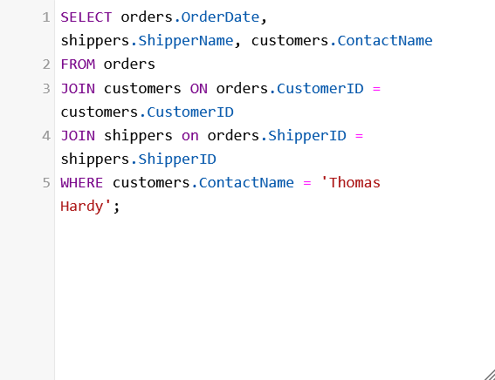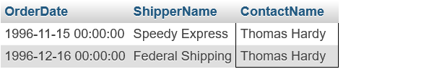

* 1. Get the employee born in January, sort by their name



* 1. Number of product for each category

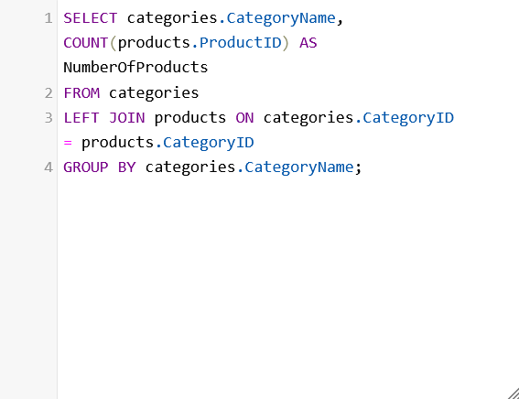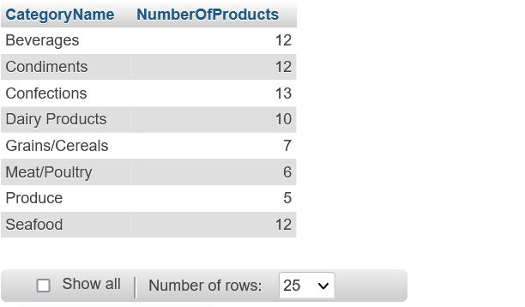

* 1. Find the most expensive product

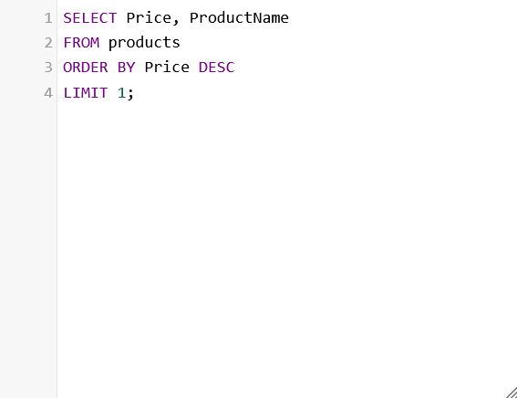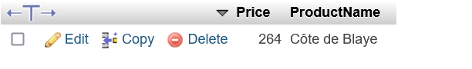

* 1. Find the average price for each category

